**Challenge 05 - Flex & Git**

For this week’s challenge, you will need to create a responsive web page and use Flex for positioning the elements. Use the screenshots to see how the page should look like.

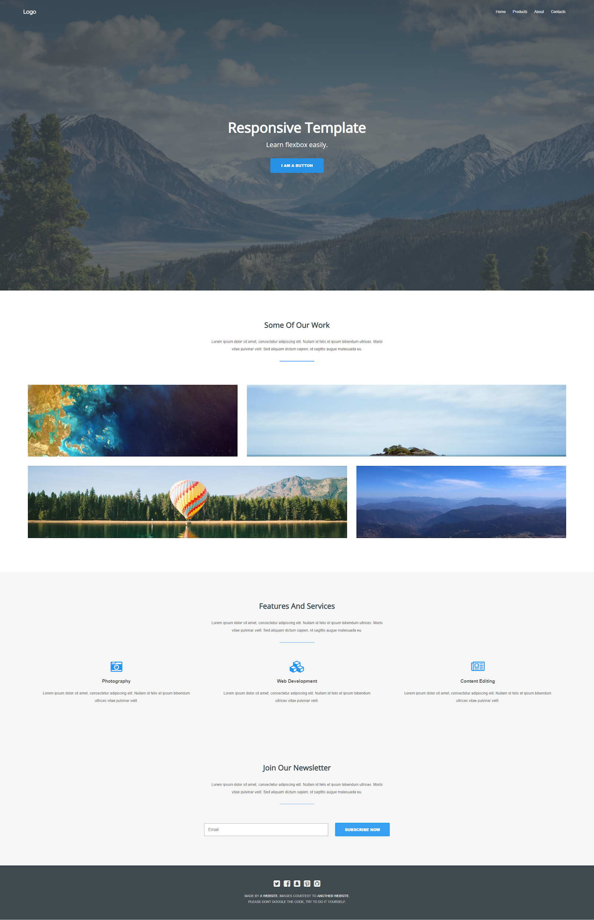 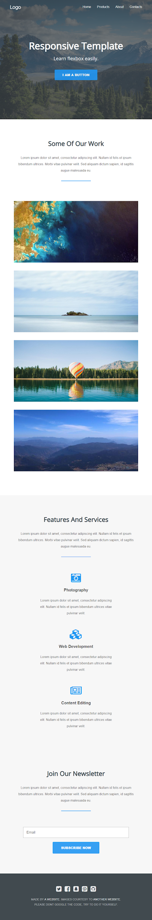 

After finishing the project, try to upload it to Git by using only terminal commands. Create a private repository and add your mentors by their GitLab username (we will share these in your slack channel).

Name your project repo **BrainsterChallenges_FirstnameLastnameGroup** (ex. BrainsterChallenges_AntonioStoimenovFE1) and leave the master branch with a readme.md file only. Initiate a new branch from master and name it **Challenge 05 - CSS Flex & Git**.

* Be careful while working with Git, you will use this repo for all the next challenges.

#### 

#### Evaluation system:

**1 point** - Whole page completed in HTML & CSS;

**3 points** - Responsive for tablet & mobile devices;

**5 points** - Project committed on [GitLab](https://gitlab.com/).

#### Deadline:

**One** week after its presentation, 23:59h end of the day.